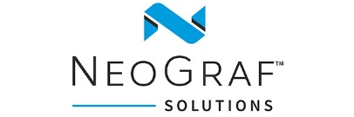

GrafGuard® Expandable Graphite Flake: The Intumescent Fire Safety
Material of Choice for Coated Roofing Underlayments

Overview
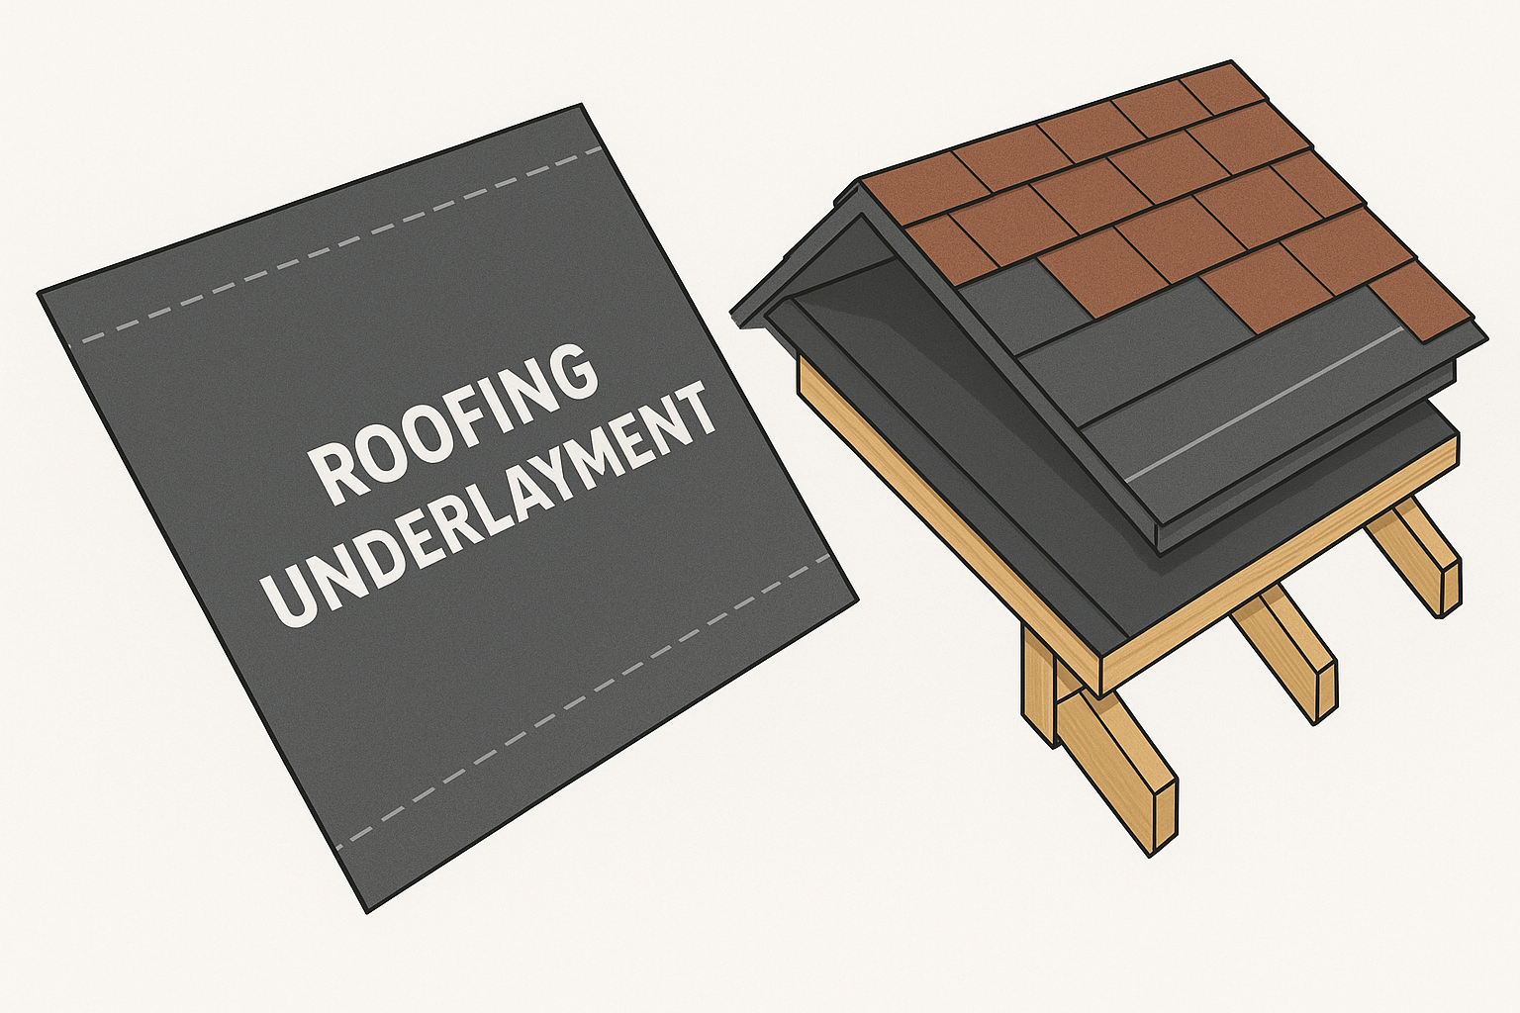
Roofing underlayments coated with GrafGuard® expandable graphite flake intumescent flame retardant provide a layer of advanced fire resistance for roofing materials. These underlayments, are positioned between the roof deck and the final roofing layer (e.g., shingles or tiles) and serve as a critical secondary barrier against moisture, weather, and fire.

The underlayment base is a synthetic fabric such as polypropylene or polyester. These base materials are then coated with substances like asphalt, bitumen, or polymer blends to enhance durability and weather resistance. To add fire protection, a coating layer with GrafGuard expandable graphite flake is incorporated into the polymer blends or as a separate layer.

Common Applications
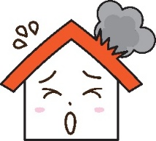
- Commercial buildings where enhanced fire protection is required by code
- Metal and tile roofing systems where limiting heat transfer through the roof deck is essential
- High risk wildfire-prone zones.
- Roofs that support solar panels

How it Works
Intumescent flame retardants expand when exposed to heat or flame, forming a charred, insulating layer that slows heat transfer, restricts oxygen access, and reduces flame spread and structural damage. Graphite-based intumescent systems rely on expandable graphite, a material that rapidly expands, often up to 100–300 times its original volume, when subjected to high temperatures.

Stages of GrafGuard expandable graphite reacting synergistically as a fire-retardant system

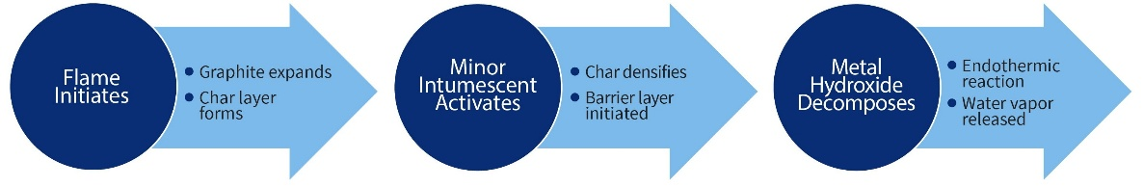

Using GrafGuard expandable graphite flake ensures a stable, thermally insulating barrier that enhances fire protection by shielding underlying materials from heat and flame exposure.

Schematic of the reactive coating char layer formation when activated by a fire separating
the polymer fuel from the fire.
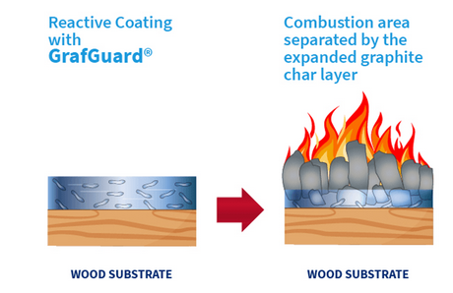

Benefits of GrafGuard Expandable Graphite Flake as a Fire Retardant

When used as part of the full roofing envelope, GrafGuard graphite intumescent flame retardants provide several key advantages.
- Enhance fire protection - Creating a thermal barrier beneath the roof, helping assemblies meet or exceed stringent fire safety standards such as ASTM E108 and UL 790 Class A ratings
- Self-extinguishing properties - Once the ignition source is removed, the material can stop burning due to the formation of an insulating intumescent char layer
- Lightweight and thin profile - The graphite intumescent layer can be integrated into coatings or films without adding significant bulk
- Promote environmental and health safety - Expandable graphite is considered an eco-friendly alternative to halogenated flame retardants and contributes to low smoke emission and reduced release of toxic gases during fire events

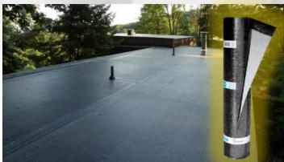
Product Configuration
Example structure of high-performance roofing underlayment with expandable graphite:
- Base Layer - Polyester scrim for mechanical strength
- Coating - Polyolefin with GrafGuard graphite
- Top Surface - UV-resistant polymer coating
- Performance - ASTM E84 Class A, UL 790 Class A fire rating

Conclusion
As fire safety regulations on residential, commercial, and solar panel systems as well as area with wildfire threats continue to evolve and become stricter, the demand for high-performance roofing solutions has never been greater. Coated roofing underlayments enhanced with GrafGuard expandable graphite flake represent a significant advancement in fire protection technology.

These underlayments not only provide a critical thermal and moisture barrier beneath roofing systems but also deliver reliable, self-extinguishing fire resistance with minimal impact on weight or profile. With applications ranging from commercial buildings to wildfire-prone residential areas, GrafGuard graphite supports compliance with rigorous fire safety standards while promoting environmental and occupant safety. GrafGuard expandable graphite flake stands out as a proven, effective solution for today’s fire-resilient roofing system.

NeoGraf Solutions ● 11709 Madison Ave, Lakewood, OH 44107 USA
PH: +1 216-529-3777 ● info@neograf.com ● www.neograf.com

